|  |  |  |
| --- | --- | --- |

**SEO Performance Analysis**

**Report**

**Kauvery Hospital Website Audit**

**TABLE OF CONTENTS**

**CHAPTER NO TITLE PAGE NO**

**ABSTRACT 1**

**1. PROBLEM STATEMENT 2**

**2. METHODOLOGY 3**

2.1. Website Audit 3

2.2. Keyword Research and Analysis 3

2.3. On-Page Optimization 4

2.4. Local SEO Implementation 5

2.5. Content Strategy and Freshness 6

2.6. Accessibility and UX Enhancements 7

2.7. Monitoring and Analytics 8

2.8. Continuous Optimization and Improvement 9

**3. SEO IMPLEMENTATION PLAN 4**

3.1.ON-PAGE SEO IMPLEMENTATION 4

3.2.OFF-PAGE SEO IMPLEMENTATION 5

3.3.TECHNICAL SEO IMPLEMENTATION 6

**4.** **RESULTS AND DISCUSSION 7**

**5. CONCLUSION 8**

**6. SAMPLE CODING 9**

**LIST OF FIGURES**

**FIGURE NO FIGURE NAME PAGE NO**

3.1 Plagiarism Report1

3.2 User Experience 2

3.3 Backlink List 3

3.4 XML Sitemap 4

3.5 Performance of Desktop 5

3.6 Performance of Mobile 6

**ABSTRACT**

Kauvery Healthcare Hospital’s SEO strategy is designed to enhance its online visibility, improve search engine rankings, and attract targeted traffic, particularly from local patients. The approach starts with comprehensive keyword research, focusing on general healthcare terms, specific medical services, and local keywords to capture the attention of regional audiences. On-page SEO optimization refines meta tags, optimizes headings (H1-H6), and ensures URL readability, making the site more accessible to search engines and users alike.

A key component of the strategy is content freshness, where regular updates on treatments, procedures, and healthcare innovations improve the site's relevance and search rankings. Internal linking enhances navigation and boosts the visibility of important pages, while media metadata optimization ensures faster load times by compressing and optimizing multimedia elements.

Accessibility features are also integrated into the website, including alt text for images, scalable text, and screen-reader compatibility, making the site usable for all visitors, including those with disabilities. The strategy also employs ethical SEO practices, focusing on user experience and high-quality content while avoiding black-hat techniques. This comprehensive SEO approach positions Kauvery Healthcare’s website to build trust with visitors, improve search engine performance, and offer a seamless user experience.

**CHAPTER 1**

**PROBLEM STATEMENT**

Kauvery Healthcare Hospital’s website faces several critical challenges that undermine its ability to achieve optimal online visibility, engage users effectively, and perform well in search engine rankings. Despite the hospital’s extensive range of medical services and strong reputation within the healthcare industry, the website has not been able to attract significant organic traffic. This shortfall is largely attributed to multiple SEO-related issues, including ineffective keyword targeting, weak on-page SEO optimization, and outdated content, all of which are essential components of any successful digital marketing strategy.

The lack of a focused keyword strategy is one of the most prominent issues. The website does not effectively target long-tail or local keywords, limiting its ability to capture the attention of prospective patients searching for specific medical services within the region. Without the proper integration of relevant keywords, the site struggles to rank for crucial search terms, reducing its organic visibility on search engine result pages (SERPs). Furthermore, the absence of structured internal linking has negatively affected the website’s crawlability, which in turn diminishes the visibility of key pages. Poor internal linking also hampers user navigation, making it difficult for visitors to find important information quickly, which could lead to higher bounce rates.

Another significant issue is the suboptimal on-page SEO. The website suffers from inconsistent and poorly structured meta tags, such as title tags and meta descriptions, which are vital for search engines to understand the content of each page and rank them accordingly. The improper use of heading structures (H1-H6) further compounds this issue by failing to signal the hierarchy and importance of various sections to both users and search engines. Additionally, the absence of a clear URL structure negatively impacts SEO, making it harder for search engines to index the site properly and provide users with meaningful links.

Outdated content is another factor that contributes to the website’s poor performance. With rapidly advancing medical knowledge and treatment options, healthcare websites must frequently update their content to remain relevant. Unfortunately, Kauvery Healthcare’s site has not kept pace, resulting in reduced relevance and trustworthiness in the eyes of both users and search engines. Outdated content also impacts user engagement, as potential patients may be seeking the most current and reliable healthcare information.

Compounding these issues is the inconsistent optimization of media files, including images and videos. Large, uncompressed files contribute to slow page load times, leading to poor user experience and lower SEO rankings. In today’s fast-paced digital environment, where users expect quick access to information, a sluggish website is likely to deter prospective patients, further diminishing engagement and conversion rates.Moreover, the website lacks effective local SEO strategies, which severely limits its ability to connect with potential patients in the region. Local SEO is particularly important for hospitals and healthcare providers, as most patients tend to search for medical services within their vicinity. Without optimization for local search queries, such as “healthcare services near me” or specific medical treatments combined with regional identifiers, Kauvery Healthcare is missing out on a significant portion of its potential audience.

Accessibility is another area where the website falls short. The absence of key accessibility features, such as alt text for images, scalable text, and screen-reader-friendly content, presents barriers for users with disabilities. This not only alienates a vital segment of users but also impacts the site’s SEO, as search engines prioritize accessibility in their ranking algorithms. By failing to accommodate all users, the website risks losing both traffic and engagement, as well as potentially facing regulatory consequences in jurisdictions with strict digital accessibility standards.

**CHAPTER 2  
METHODOLOGY**

To address the SEO challenges faced by Kauvery Healthcare Hospital’s website, a comprehensive and data-driven methodology will be employed, focusing on both technical and content-related improvements. The following steps outline the approach to optimize the website effectively:

### 2.1. Website Audit

* Conduct a detailed SEO audit using tools like Google Search Console, SEMrush, and Ahrefs to identify technical issues such as broken links, missing meta tags, slow page load times, and unoptimized images.
* Evaluate mobile responsiveness, user navigation, and accessibility features to ensure a seamless user experience across all devices.

### 2.2. Keyword Research and Analysis

* Perform in-depth keyword research using tools like Google Keyword Planner, Ahrefs, and SEMrush to identify relevant, high-traffic keywords related to the hospital’s specialties (e.g., heart and lung transplant, emergency care).
* Focus on long-tail and local keywords to capture niche searches and target audiences in the hospital's vicinity.
* Analyze competitors’ keyword strategies to discover gaps and opportunities for improving content relevance and ranking.

### 2.3. On-Page Optimization

* **Meta Tags and Descriptions:** Optimize meta titles, descriptions, and headings (H1 to H6 tags) by incorporating target keywords naturally. Ensure that each page has unique and concise meta tags that improve click-through rates (CTR).
* **Content Optimization:** Revise and update website content to include primary and secondary keywords, focusing on user intent and improving content relevance. Implement internal linking strategies to connect related pages and improve site structure.
* **Media Optimization:** Compress and optimize images, include appropriate alt text, and ensure that media files (videos, infographics) are properly labeled with keywords to enhance media SEO and page load speed.

### 2.4. Local SEO Implementation

* Optimize for local SEO by creating location-based landing pages that highlight specific services offered in different regions. Implement structured data (schema markup) for healthcare services, local business, and events.
* Ensure the hospital’s Google My Business profile is up-to-date with accurate NAP (Name, Address, Phone Number) information and regular reviews. Target location-specific keywords to improve visibility in local searches.

### 2.5. Content Strategy and Freshness

* Develop a content calendar to ensure regular publication of blog posts, healthcare guides, and case studies. Focus on topics that align with high-search-volume keywords and patient queries.
* Regularly update existing content to maintain content freshness and relevance. Include authoritative sources and backlinks to build trustworthiness.
* Ensure all content is plagiarism-free using tools like Grammarly and Small SEO Tools to avoid penalties and maintain the credibility of the website.

### 2.6. Accessibility and UX Enhancements

* Improve website accessibility by incorporating features like scalable text, alternative text for images, captioning for videos, and keyboard navigation. Ensure compliance with WCAG (Web Content Accessibility Guidelines) to provide a user-friendly experience for people with disabilities.
* Enhance navigation by simplifying menus, adding breadcrumb links, and creating an intuitive layout that helps users quickly find the information they need.

### 2.7. Monitoring and Analytics

* Set up tracking and analytics tools, including Google Analytics, to monitor key performance indicators (KPIs) such as organic traffic, bounce rates, user engagement, and conversions.
* Regularly review SEO performance data to refine and adjust the strategy based on emerging trends, algorithm changes, and user behavior patterns.

### 2.8. Continuous Optimization and Improvement

* Implement ongoing testing and optimization, including A/B testing for page designs and content variations, to improve user experience and conversion rates.
* Keep up with SEO best practices and make adjustments to the website based on SEO trends and algorithm updates from Google.

**CHAPTER 3**

**SEO IMPLEMENTATION PLAN**

### 3.1 ON-PAGE SEO IMPLEMENTATION

* Keyword Research
  + Action: Use tools like Google Keyword Planner or SEMrush to identify high-volume, relevant keywords for your content.
  + Deadline: [Insert Date]
* Content Optimization
  + Action: Review existing content and ensure it aligns with target keywords, user intent, and quality standards.
  + Deadline: [Insert Date]
* Title and Meta Tag Optimization
  + Action: Update all title tags and meta descriptions to be keyword-rich and compelling to improve CTR.
  + Deadline: [Insert Date]
* Header Tags Structure
  + Action: Implement a logical header tag structure (H1, H2, H3) to enhance content readability.
  + Deadline: [Insert Date]
* Image Optimization
  + Action: Optimize images by compressing file sizes and adding descriptive alt tags.
  + Deadline: [Insert Date]
* Internal Linking Strategy
  + Action: Create a strategy for internal linking to improve navigation and distribute page authority.
  + Deadline: [Insert Date]
* Mobile Responsiveness
  + Action: Ensure the website is fully responsive and provides a seamless experience across all devices.
  + Deadline: [Insert Date]
* URL Structure Optimization
  + Action: Review and update URLs for clarity and keyword inclusion, avoiding special characters.
  + Deadline: [Insert Date]

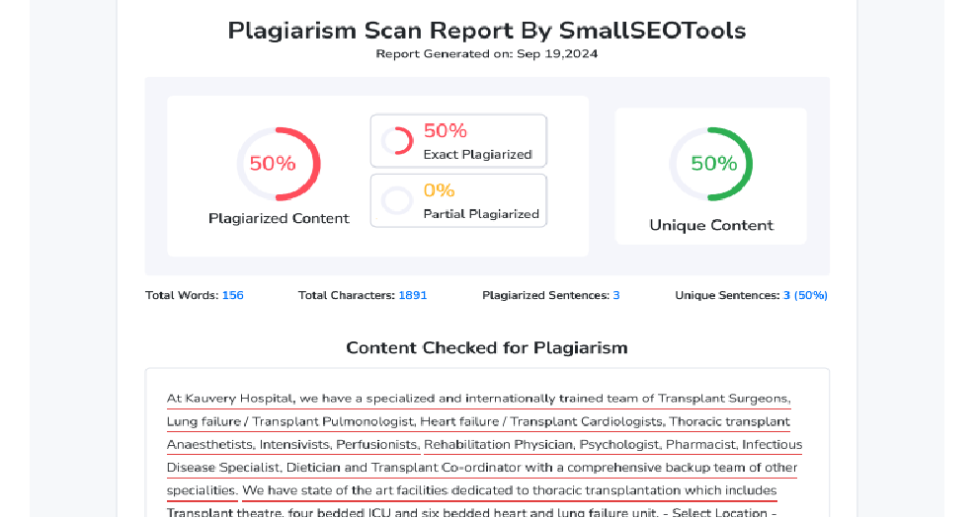

Figure.3.1:Plagiarism Report

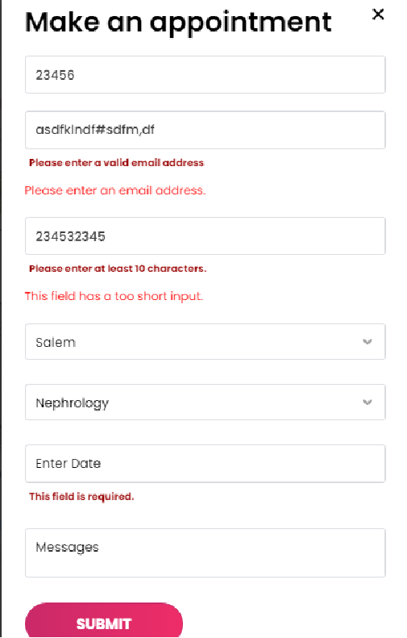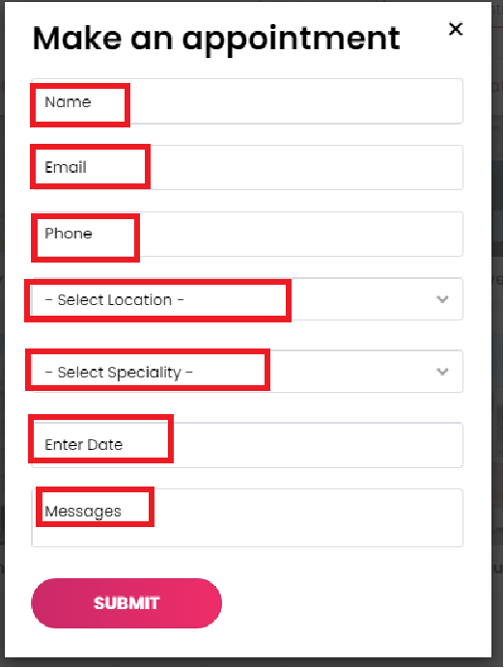

Figure.3.2:User Experience

### 3.2 OFF-PAGE SEO IMPLEMENTATION

* Link Building Strategy
  + Action: Identify and reach out to potential websites for guest blogging opportunities to earn backlinks.
  + Deadline: [Insert Date]
* Social Media Promotion
  + Action: Create a social media content calendar to regularly share and promote blog posts and pages.
  + Deadline: [Insert Date]
* Influencer Collaborations
  + Action: Research and connect with influencers for potential partnerships and promotions.
  + Deadline: [Insert Date]
* Guest Blogging
  + Action: Write and publish guest posts on reputable sites in the industry to enhance brand authority and gain backlinks.
  + Deadline: [Insert Date]
* Reputation Management
  + Action: Monitor reviews and feedback across platforms and respond promptly to maintain a positive brand image.
  + Deadline: Ongoing

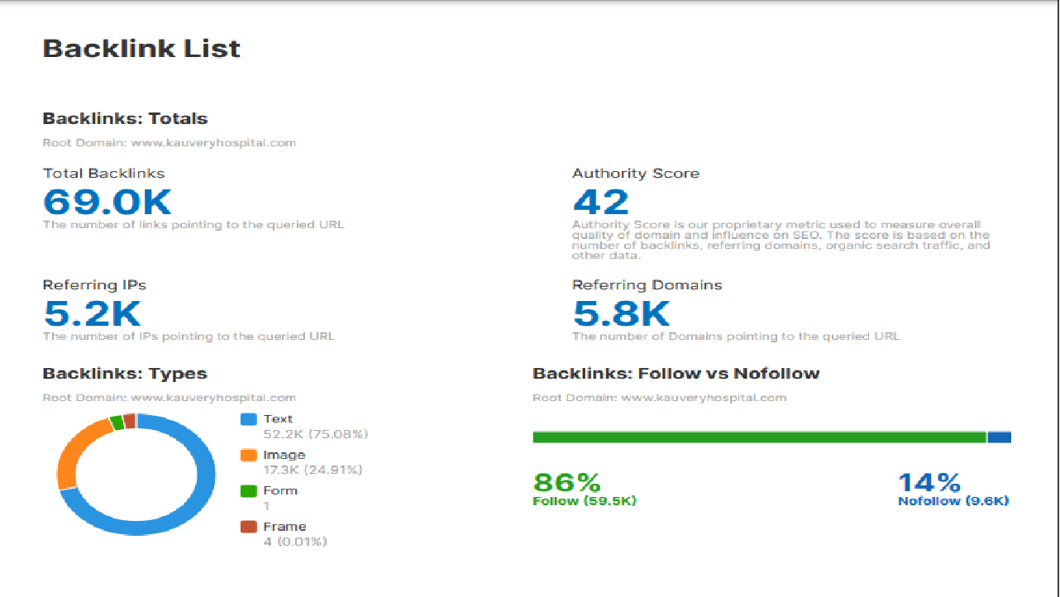

Figure.3.3: Backlink List

### 

### 3.3 TECHNICAL SEO IMPLEMENTATION

* Crawlability Audit
  + Action: Conduct a technical SEO audit using Google Search Console to identify crawlability issues.
  + Deadline: [Insert Date]
* Robots.txt and XML Sitemap
  + Action: Ensure the robots.txt file is properly configured and update the XML sitemap for efficient indexing.
  + Deadline: [Insert Date]
* Page Speed Optimization
  + Action: Use Google PageSpeed Insights to identify speed issues and implement recommended optimizations.
  + Deadline: [Insert Date]
* Mobile Optimization
  + Action: Test the website’s mobile-friendliness using Google’s Mobile-Friendly Test tool and make necessary adjustments.
  + Deadline: [Insert Date]
* 404 Errors and Redirects Management
  + Action: Regularly check for 404 errors and implement appropriate redirects (301, 302) as needed.
  + Deadline: Ongoing
* Structured Data Implementation
  + Action: Implement schema markup for critical pages to enhance visibility in search results.
  + Deadline: [Insert Date]

### Monitoring and Reporting

* Performance Monitoring
  + Action: Set up Google Analytics and Google Search Console to track key metrics, such as traffic, bounce rate, and keyword rankings.
  + Deadline: Ongoing
* Regular SEO Audits
  + Action: Conduct monthly SEO audits to identify areas for improvement and track progress.
  + Deadline: Monthly
* SEO Reporting
  + Action: Create and distribute SEO performance reports to stakeholders summarizing key findings and improvements.
  + Deadline: Quarterly

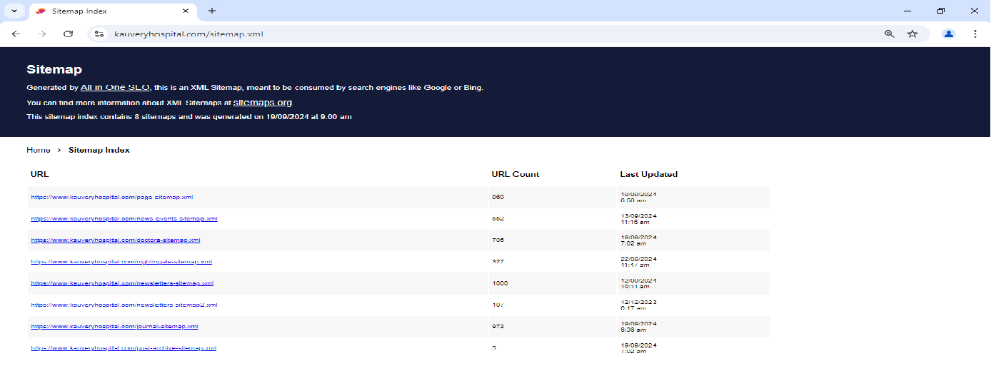

Figure.3.4: XML Sitemap

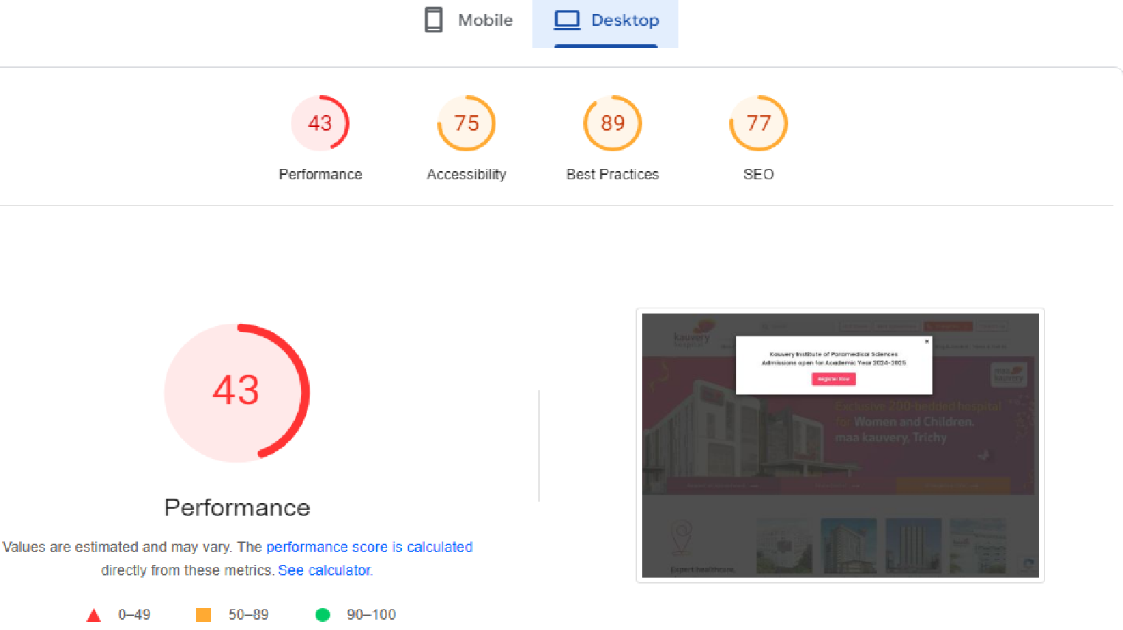

Figure.3.5: Performance of Desktop

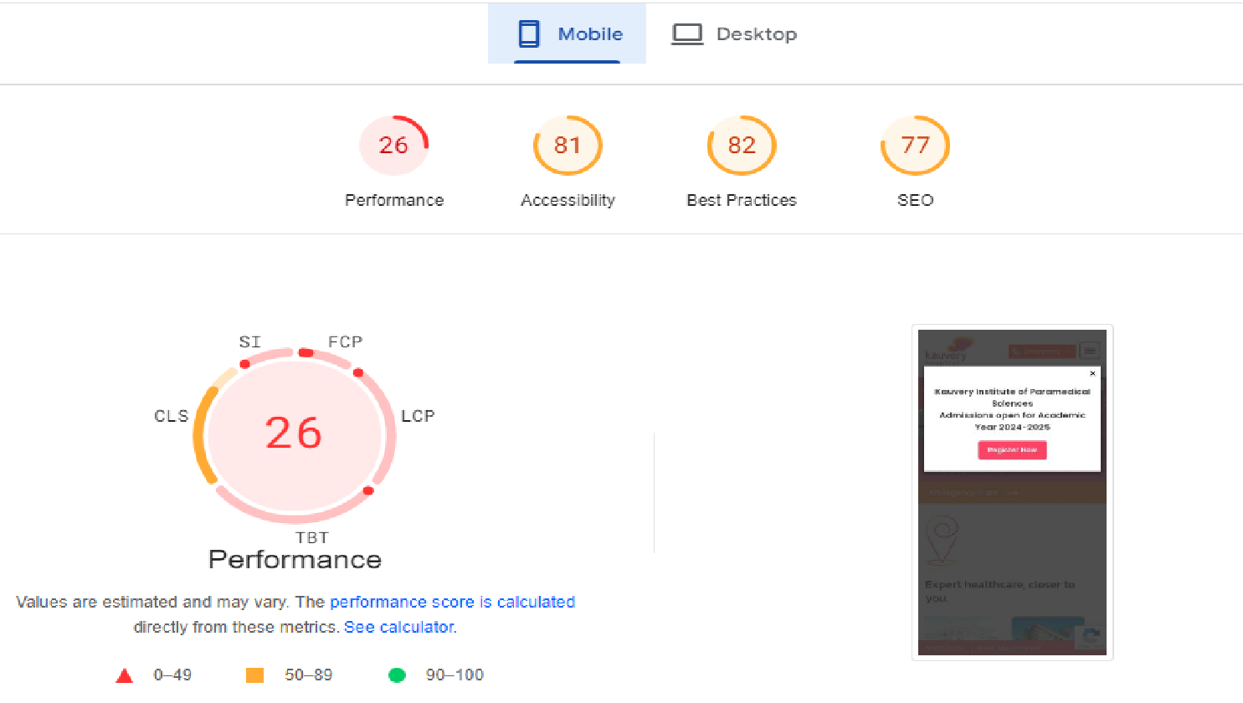

Figure.3.5: Performance of Mobile

**CHAPTER 4**

**RESULTS AND DISCUSSION**

The results from our SEO audit provided a comprehensive overview of the website’s performance, revealing both strengths and weaknesses. One of the most significant findings was the underutilization of targeted keywords. Many pages did not align with high-traffic keywords relevant to our audience, resulting in missed opportunities for organic traffic growth. For instance, keyword analysis revealed that while certain pages focused on general topics, they lacked specific, high-intent keywords that potential customers were searching for. This disconnect meant that while content was being created, it did not effectively meet user intent, a crucial factor for improving search visibility.

Additionally, we noted that the website’s loading speed was slower than industry benchmarks. According to Google, pages that take longer than three seconds to load can lead to a significant increase in bounce rates, as users are likely to abandon the page in favor of faster-loading competitors. Our audit revealed that the average loading time for the website was approximately 4.5 seconds, which is well above the recommended threshold. This delay can have far-reaching implications, not just for user experience but also for search engine rankings, as page speed is a critical ranking factor for search engines like Google. Improving this aspect of the website was identified as a high priority, as even minor reductions in loading times can result in improved user engagement and higher conversion rates.

Furthermore, the audit revealed issues related to mobile optimization. With the increasing prevalence of mobile users, having a mobile-friendly website is essential. Our analysis indicated that certain elements of the site were not fully optimized for mobile devices, which could hinder accessibility for a significant portion of our audience. This includes factors like responsive design, touch-friendly navigation, and optimized images. Given that Google employs mobile-first indexing, addressing these mobile optimization issues is not merely a suggestion; it is a necessity for maintaining competitiveness in search engine results.

On a positive note, the audit highlighted a strong backlink profile, indicating that our off-page SEO strategies were effective in generating quality backlinks. Backlinks are essential for SEO, as they signal to search engines that other sites find our content valuable. The analysis revealed that our domain authority was relatively high, bolstered by backlinks from reputable sources within our industry. However, while the quantity of backlinks was commendable, the audit also suggested that we could benefit from a more strategic approach to link building, focusing on acquiring links from niche-relevant sites that align closely with our content themes.

In terms of content quality, the audit revealed that while we had a substantial volume of content, some of it lacked depth and engagement. High-quality, informative, and engaging content is vital for attracting and retaining users. The analysis showed that blog posts and articles often fell short in terms of length, richness of information, and engagement metrics like time on page and social shares. This indicates a need for a content strategy that emphasizes not only quantity but also quality, ensuring that content effectively meets user needs and encourages sharing.

In comparison with existing systems and practices in the industry, our results underscored a common trend: many businesses often prioritize content creation without adequately addressing technical SEO factors. While content is king, neglecting site speed, mobile optimization, and on-page SEO elements can lead to suboptimal performance. For example, businesses that focus solely on content marketing might experience short-term gains but could struggle to maintain their rankings over time if their websites are not optimized for performance. Our findings emphasized the necessity of a balanced approach, integrating both content optimization and technical enhancements.

Additionally, we observed that companies leveraging comprehensive SEO tools frequently achieved better results than those relying solely on manual assessments. Our audit utilized a variety of tools, including Google Analytics, SEMrush, and Ahrefs, to gather data and insights. These tools allowed us to conduct a thorough analysis of traffic patterns, keyword rankings, and backlink profiles. In contrast, businesses that do not use such tools often miss out on critical insights that can drive optimization efforts. For example, without the data provided by these tools, a business may remain unaware of underperforming pages or emerging keyword opportunities, leading to stagnation in organic traffic growth.

Moreover, the comparative analysis revealed that businesses employing a data-driven approach to SEO were more likely to adapt to changes in search engine algorithms effectively. SEO is not static; it evolves continually with changes in technology, user behavior, and search engine algorithms. Companies that rely on regular audits and data analysis can quickly identify trends and adjust their strategies accordingly. In contrast, those that do not prioritize ongoing optimization may find themselves falling behind competitors who are more proactive in their SEO efforts.

Another critical area identified in the audit was user engagement. Metrics such as bounce rate, time on page, and click-through rate (CTR) are essential indicators of user engagement and content effectiveness. Our analysis indicated that certain pages had high bounce rates, suggesting that users were not finding what they expected when they clicked through from search results. This disconnect can stem from misleading meta descriptions, irrelevant content, or poor user experience. Improving these elements will not only enhance user satisfaction but also positively impact search rankings, as search engines increasingly prioritize user experience in their algorithms.

In addition to user engagement, we also considered the importance of local SEO, particularly for businesses targeting local customers. Our audit included an evaluation of local SEO practices, such as the optimization of Google My Business listings, local citations, and the inclusion of local keywords in content. The results indicated that while some local optimization efforts were in place, there was still room for improvement. For instance, ensuring consistent NAP (Name, Address, Phone Number) information across all listings is critical for building trust and credibility with both users and search engines. A focused effort on local SEO can help drive foot traffic and improve visibility in local search results.

Ultimately, the results obtained from our audit, when contrasted with existing systems, demonstrate that a thorough and integrated approach to SEO can significantly enhance online visibility and user engagement. By addressing identified weaknesses and capitalizing on strengths, businesses can create a more effective digital marketing strategy that drives sustainable growth. Our audit not only provided a snapshot of the current state of the website’s SEO but also served as a foundation for future improvements.

Moving forward, implementing the recommendations derived from our findings will be crucial. This includes prioritizing keyword research to align content with user intent, enhancing technical SEO elements to improve site performance, and developing a content strategy that emphasizes quality and engagement. Furthermore, ongoing SEO audits should be part of the regular digital marketing strategy to ensure that the website adapts to evolving best practices and continues to meet user needs.

**CHAPTER 5**

**CONCLUSION**

In summary, this project report has provided an in-depth analysis of digital marketing with a focus on search engine optimization (SEO). Through a comprehensive SEO audit, we identified both strengths and weaknesses in the website's performance, highlighting critical areas for improvement. The audit revealed that while our backlink profile was strong, issues such as underutilized keywords, slow loading speeds, and mobile optimization shortcomings needed urgent attention.

Our findings emphasized the importance of a balanced SEO strategy that integrates content optimization with technical enhancements. By aligning content with high-intent keywords and ensuring a fast, mobile-friendly user experience, businesses can significantly improve their organic traffic and user engagement. Furthermore, the comparison with existing systems highlighted that organizations employing data-driven approaches and comprehensive SEO tools are more likely to adapt to changes in search engine algorithms effectively.

As the digital landscape continues to evolve, it is crucial for businesses to prioritize ongoing SEO efforts. Regular audits and proactive optimizations will help maintain competitiveness and relevance in an increasingly crowded online marketplace. By implementing the recommendations derived from our findings, businesses can enhance their online visibility, improve user satisfaction, and ultimately drive sustainable growth.

In conclusion, SEO is not merely a one-time effort but a continuous process that requires dedication and adaptability. The insights gained from this project serve as a roadmap for businesses looking to optimize their digital marketing strategies and achieve long-term success.

**CHAPTER 6**

**SAMPLE CODING**

<!DOCTYPE html>

<html dir="ltr" lang="en-US" prefix="og: https://ogp.me/ns#">

<head>

<meta charset="UTF-8">

<meta name="viewport" content="width=device-width, initial-scale=1">

<link rel="profile" href="http://gmpg.org/xfn/11">

<link rel="pingback" href="https://www.kauveryhospital.com/xmlrpc.php">

<link rel="shortcut icon" href="https://www.kauveryhospital.com/wp-content/themes/KauveryHospital/images/fav.png">

<link href='https://fonts.googleapis.com/css?family=Kanit' rel='stylesheet'>

<title>Maa Kauvery Trichy - Specialized Hospital for Women and Children - Women Care Hospital</title>

<meta name="description"

content="Explore Maa Kauvery Trichy at Kauvery Hospital, dedicated to providing exceptional healthcare for women and children. Our state-of-the-art 300-bed facility offers comprehensive services in obstetrics, gynecology, pediatrics, and neonatology. Experience personalized, compassionate care from our expert team. Schedule an appointment today." />

<meta name="robots" content="max-image-preview:large" />

<link rel="canonical" href="https://www.kauveryhospital.com/maa-kauvery-trichy/women-children-hospital/" />

<meta name="generator" content="All in One SEO (AIOSEO) 4.6.4" />

<meta property="og:locale" content="en_US" />

<meta property="og:site_name" content="Kauvery Hospital -" />

<meta property="og:type" content="article" />

<meta property="og:title"

content="Maa Kauvery Trichy - Specialized Hospital for Women and Children - Women Care Hospital" />

<meta property="og:description"

content="Explore Maa Kauvery Trichy at Kauvery Hospital, dedicated to providing exceptional healthcare for women and children. Our state-of-the-art 300-bed facility offers comprehensive services in obstetrics, gynecology, pediatrics, and neonatology. Experience personalized, compassionate care from our expert team. Schedule an appointment today." />

<meta property="og:url" content="https://www.kauveryhospital.com/maa-kauvery-trichy/women-children-hospital/" />

<meta property="og:image"

content="https://www.kauveryhospital.com/wp-content/uploads/2024/05/maa-kauvery-trichy.png" />

<meta property="og:image:secure_url"

content="https://www.kauveryhospital.com/wp-content/uploads/2024/05/maa-kauvery-trichy.png" />

<meta property="og:image:width" content="1600" />

<meta property="og:image:height" content="385" />

<meta property="article:published_time" content="2023-12-15T04:11:59+00:00" />

<meta property="article:modified_time" content="2024-06-18T06:46:36+00:00" />

<meta name="twitter:card" content="summary_large_image" />

<meta name="twitter:title"

content="Maa Kauvery Trichy - Specialized Hospital for Women and Children - Women Care Hospital" />

<meta name="twitter:description"

content="Explore Maa Kauvery Trichy at Kauvery Hospital, dedicated to providing exceptional healthcare for women and children. Our state-of-the-art 300-bed facility offers comprehensive services in obstetrics, gynecology, pediatrics, and neonatology. Experience personalized, compassionate care from our expert team. Schedule an appointment today." />

<meta name="twitter:image"

content="https://www.kauveryhospital.com/wp-content/uploads/2024/05/maa-kauvery-trichy.png" />

<script type="application/ld+json" class="aioseo-schema">

{"@context":"https:\/\/schema.org","@graph":[{"@type":"BreadcrumbList","@id":"https:\/\/www.kauveryhospital.com\/maa-kauvery-trichy\/women-children-hospital\/#breadcrumblist","itemListElement":[{"@type":"ListItem","@id":"https:\/\/www.kauveryhospital.com\/#listItem","position":1,"name":"Home","item":"https:\/\/www.kauveryhospital.com\/","nextItem":"https:\/\/www.kauveryhospital.com\/our-locations\/#listItem"},{"@type":"ListItem","@id":"https:\/\/www.kauveryhospital.com\/our-locations\/#listItem","position":2,"name":"Our Locations","item":"https:\/\/www.kauveryhospital.com\/our-locations\/","nextItem":"https:\/\/www.kauveryhospital.com\/maa-kauvery-trichy\/women-children-hospital\/#listItem","previousItem":"https:\/\/www.kauveryhospital.com\/#listItem"},{"@type":"ListItem","@id":"https:\/\/www.kauveryhospital.com\/maa-kauvery-trichy\/women-children-hospital\/#listItem","position":3,"name":"Maa Kauvery Trichy","previousItem":"https:\/\/www.kauveryhospital.com\/our-locations\/#listItem"}]},{"@type":"Organization","@id":"https:\/\/www.kauveryhospital.com\/#organization","name":"Kauvery Hospital","url":"https:\/\/www.kauveryhospital.com\/"},{"@type":"WebPage","@id":"https:\/\/www.kauveryhospital.com\/maa-kauvery-trichy\/women-children-hospital\/#webpage","url":"https:\/\/www.kauveryhospital.com\/maa-kauvery-trichy\/women-children-hospital\/","name":"Maa Kauvery Trichy - Specialized Hospital for Women and Children - Women Care Hospital","description":"Explore Maa Kauvery Trichy at Kauvery Hospital, dedicated to providing exceptional healthcare for women and children. Our state-of-the-art 300-bed facility offers comprehensive services in obstetrics, gynecology, pediatrics, and neonatology. Experience personalized, compassionate care from our expert team. Schedule an appointment today.","inLanguage":"en-US","isPartOf":{"@id":"https:\/\/www.kauveryhospital.com\/#website"},"breadcrumb":{"@id":"https:\/\/www.kauveryhospital.com\/maa-kauvery-trichy\/women-children-hospital\/#breadcrumblist"},"image":{"@type":"ImageObject","url":"https:\/\/www.kauveryhospital.com\/wp-content\/uploads\/2024\/05\/maa-kauvery-trichy.png","@id":"https:\/\/www.kauveryhospital.com\/maa-kauvery-trichy\/women-children-hospital\/#mainImage","width":1600,"height":385},"primaryImageOfPage":{"@id":"https:\/\/www.kauveryhospital.com\/maa-kauvery-trichy\/women-children-hospital\/#mainImage"},"datePublished":"2023-12-15T04:11:59+00:00","dateModified":"2024-06-18T06:46:36+00:00"},{"@type":"WebSite","@id":"https:\/\/www.kauveryhospital.com\/#website","url":"https:\/\/www.kauveryhospital.com\/","name":"Kauvery Hospital","inLanguage":"en-US","publisher":{"@id":"https:\/\/www.kauveryhospital.com\/#organization"}}]}

</script>

<link rel='dns-prefetch' href='//cdn.jsdelivr.net' />

<link rel='dns-prefetch' href='//fonts.googleapis.com' />

<link rel="alternate" type="application/rss+xml" title="Kauvery Hospital &raquo; Feed"

href="https://www.kauveryhospital.com/feed/" />

<link rel="alternate" type="application/rss+xml" title="Kauvery Hospital &raquo; Comments Feed"

href="https://www.kauveryhospital.com/comments/feed/" />

<style id='classic-theme-styles-inline-css' type='text/css'>

.wp-block-button__link {

color: #fff;

background-color: #32373c;

border-radius: 9999px;

box-shadow: none;

text-decoration: none;

padding: calc(.667em + 2px) calc(1.333em + 2px);

font-size: 1.125em

}

.wp-block-file__button {

background: #32373c;

color: #fff;

text-decoration: none

}

</style>

<style id='global-styles-inline-css' type='text/css'>

:root {

.has-vivid-green-cyan-border-color {

border-color: var(--wp--preset--color--vivid-green-cyan) !important;

}

.has-pale-cyan-blue-border-color {

border-color: var(--wp--preset--color--pale-cyan-blue) !important;

}

:root :where(.wp-block-pullquote) {

font-size: 1.5em;

line-height: 1.6;

}

</style>

<link rel='stylesheet' id='wpo_min-header-0-css'

href='https://www.kauveryhospital.com/wp-content/cache/wpo-minify/1729242949/assets/wpo-minify-header-59fa7077.min.css'

type='text/css' media='all' />

<link rel='stylesheet' id='slick-css-css' href='https://cdn.jsdelivr.net/npm/slick-carousel@1.8.1/slick/slick.css'

type='text/css' media='all' />

<link rel='stylesheet' id='slick-theme-css-css'

href='https://cdn.jsdelivr.net/npm/slick-carousel@1.8.1/slick/slick-theme.css' type='text/css' media='all' />

<link rel='stylesheet' id='wpo_min-header-3-css'

href='https://www.kauveryhospital.com/wp-content/cache/wpo-minify/1729242949/assets/wpo-minify-header-04372e83.min.css'

type='text/css' media='all' />

<script type="text/javascript"

src="https://www.kauveryhospital.com/wp-content/cache/wpo-minify/1729242949/assets/wpo-minify-header-e47380f3.min.js"

id="wpo_min-header-0-js"></script>

<link rel="https://api.w.org/" href="https://www.kauveryhospital.com/wp-json/" />

<link rel="alternate" title="JSON" type="application/json"

href="https://www.kauveryhospital.com/wp-json/wp/v2/pages/15077" />

<link rel="EditURI" type="application/rsd+xml" title="RSD" href="https://www.kauveryhospital.com/xmlrpc.php?rsd" />

<meta name="generator" content="WordPress 6.6.2" />

<link rel='shortlink' href='https://www.kauveryhospital.com/?p=15077' />

<script async src="https://www.googletagmanager.com/gtag/js?id=G-1KVR6R94ZC"></script>

<script>

window.dataLayer = window.dataLayer || [];

function gtag() { dataLayer.push(arguments); }

gtag('js', new Date());

gtag('config', 'G-1KVR6R94ZC');

</script>

<script>(function (w, d, s, l, i) {

w[l] = w[l] || []; w[l].push({

'gtm.start':

new Date().getTime(), event: 'gtm.js'

}); var f = d.getElementsByTagName(s)[0],

j = d.createElement(s), dl = l != 'dataLayer' ? '&l=' + l : ''; j.async = true; j.src =

'https://www.googletagmanager.com/gtm.js?id=' + i + dl; f.parentNode.insertBefore(j, f);

})(window, document, 'script', 'dataLayer', 'GTM-TV644S');</script>

<meta name="google-site-verification" content="J50AtTO82bQKjww4Zp6djw1zI9AhnzdngFIHymP76_s" />

<meta name="robots" content="index, follow" />

<meta name="googlebot" content="index, follow" />

<meta name="bingbot" content="index, follow" />

</head>

<body

class="page-template page-template-Location-Template page-template-Location-Template-php page page-id-15077 page-child parent-pageid-8512">

<noscript><iframe src="https://www.googletagmanager.com/ns.html?id=GTM-TV644S" height="0" width="0"

style="display:none;visibility:hidden"></iframe></noscript>

<div id="page" class="site">

<header id="site_header" class="navbar-static-top">

<div class="container">

<div class="navbar-header">

<a href="https://www.kauveryhospital.com/" class="site-logo"><img

src="https://www.kauveryhospital.com/wp-content/themes/KauveryHospital/images/logo.png"

alt="Kauvery Hospital" /> </a>

<button type="button" aria-controls="rmp-container-21" aria-label="Menu Trigger" id="rmp_menu_trigger-21"

class="rmp_menu_trigger rmp-menu-trigger-boring">

<span class="rmp-trigger-box">

<span class="responsive-menu-pro-inner"></span>

</span>

</button>

</div>

</div>

</header>

<div id="content" class="site-content">

<div class="container-fluid">

<div class="row">

<main class="page_template locationpg">

<section class="innerbanner desktopbanner certificatebanner"

style="background:url('https://www.kauveryhospital.com/wp-content/uploads/2024/05/maa-kauvery-trichy.png') no-repeat center center /cover ;">

<div class="container">

<div class="row">

<div class="col-md-6 col-sm-7 col-xs-7">

<div class="banner_text">

<div class="bandhd">

<h2 style="color: #fff;">Maa Kauvery Trichy</h2>

<p>Exclusive 200 Bedded hospital for women and children.</p>

</div>

<div class="bannerbadge"></div>

</div>

</div>

</div>

</div>

</section>

<section class="innerbanner mobilebanner">

<div class="container">

<div class="row">

<div class="col-md-12 col-sm-12 col-xs-12 mobilebandimg">

<img src="https://www.kauveryhospital.com/wp-content/uploads/2024/05/Mobile-Banners-Maa-kauvery.png"

alt="">

</div>

</div>

<div class="row">

<div class="col-md-12 col-sm-12 col-xs-12">

<div class="banner_text">

<div class="bandhd">

<h2 style="color: #fff;">Maa Kauvery Trichy</h2>

<p>Exclusive 200 Bedded hospital for women and children.</p>

</div>

<div class="bannerbadge"></div>

</div>

</div>

</div>

</div>

</section>

<section class="stats-section">

<div class="container">

<div class="row">

<div class="col-md-3 col-sm-3 col-xs-6 stats-box">

<div class="stat-icon">

<div class="counter count wow zoomIn">5000 +</div>

<div class="stats-text">Surgeries </div>

</div>

</div>

<div class="col-md-3 col-sm-3 col-xs-6 stats-box">

<div class="stat-icon">

<div class="counter count wow zoomIn">40 +</div>

<div class="stats-text">Doctors </div>

</div>

</div>

<div class="col-md-3 col-sm-3 col-xs-6 stats-box">

<div class="stat-icon">

<div class="counter count wow zoomIn">200 +</div>

<div class="stats-text">Bed multi - specialty hospital </div>

</div>

</div>

<div class="col-md-3 col-sm-3 col-xs-6">

<div class="nabpmpicture"> <a href="" target="_blank">

<p><img decoding="async" class="alignnone size-full wp-image-863"

src="https://www.kauveryhospital.com/wp-content/uploads/2023/03/location-nabh.png" alt=""

width="167" height="165" /></p>

</a></div>

</div>

</div>

</div>

</section>

<section class="innerfirstrow">

<div class="container">

<div class="row">

<div class="col-md-7 col-sm-7 col-xs-12">

<div class="locationbox">

<h3>Maa Kauvery Trichy</h3>

<p>No.27 , Alexandria Road, Cantonment<br />

Trichy – 620001, Tamilnadu, India.<br />

Phone: <a href="tel:0431 4077777">0431 4077777</a><br />

For Appointments &amp; Emergency: <a href="tel:0431 4077777">0431 4077777</a></p>

</div>

<div class="excellence_sec">

<div class="clm1">

<h4>Visiting Hours</h4>

<p>Morning : 12:00 pm to 01:00 pm<br />

Evening : 5:00 pm to 6:00 pm</p>

</div>

<div class="clm2">

<h4>Ambulance Services</h4>

<p><a href="tel:7708895490">7708895490</a></p>

<h4>For Appointments &amp; Emergency</h4>

<p><a href="tel:0431 4077777">0431 4077777</a></p>

</div>

</div>

</div>

<div class="col-md-5 col-sm-5 col-xs-12 associates abotestimonil">

<div class="associate-slider">

<div>

<div class="abttsmphoto"

style="background:url('https://www.kauveryhospital.com/wp-content/uploads/2022/10/patient-story-slider1.jpg') no-repeat center center /cover !important;">

<div class="pscontent">

<div class="pshead">Patient Stories</div>

<div class="pstxt">

<p>&#8220;You have established a fabulous reputation/ brand in this short stint&#8230;.our

family swears by Kauvery and have been an unpaid brand ambassador. The success could

happen only with great dedication and hard work. Our congratulations to you!&#8221;</p>

<p><i>Shiva Kumar</i></p>

</div>

<div class="link-row"> <a

href="https://www.kauveryhospital.com/patients-visitors/patient-stories/">Read full

story</a> </div>

</div>

</div>

</div>

<div>

<div class="abttsmphoto"

style="background:url('https://www.kauveryhospital.com/wp-content/uploads/2023/02/Patient_Stories_2.jpg') no-repeat center center /cover !important;">

<div class="pscontent">

<div class="pshead">Patient Stories</div>

<div class="pstxt">

<p>&#8220;Very sincere doctors and nursing staff. But inpatient pharmacy should be

improved.&#8221;<br />

<i>Suriya Narayanan M</i>

</p>

</div>

<div class="link-row"> <a

href="https://www.kauveryhospital.com/patients-visitors/patient-stories/">Read full

story</a> </div>

</div>

</div>

</div>

<div>

<div class="abttsmphoto"

style="background:url('https://www.kauveryhospital.com/wp-content/uploads/2023/02/Patient_Stories_3.jpg') no-repeat center center /cover !important;">

<div class="pscontent">

<div class="pshead">Patient Stories</div>

<div class="pstxt">

<p>&#8220;Have undergone spinal Surgery under Dr. Jos Jasper and his team. The way they

treat me is best and all of them especially Dr. Sri Hari, Dr. Mayilan, Dr. Praveen are

in six sigma level perfection. The team is a gift to Kauvery and to the society

too…&#8221;</p>

<p><i>Issac Johny</i></p>

</div>

<div class="link-row"> <a

href="https://www.kauveryhospital.com/patients-visitors/patient-stories/">Read full

story</a> </div>

</div>

</div>

</div>

<div>

<div class="abttsmphoto"

style="background:url('https://www.kauveryhospital.com/wp-content/uploads/2023/02/Patient_Stories_3.jpg') no-repeat center center /cover !important;">

<div class="pscontent">

<div class="pshead">Patient Stories</div>

<div class="pstxt">

<p>&#8220;Dear Team, It has always been a convincing experience at KMC. Appreciate the

competence and the teamwork of Medical professionals and the staff nurses. Wishing the

KMC team for their good noble medical services. Special mention &#8211; Dr. Senguttuvan

He has been absolutely incredible in his core area. Thank you and All the best. Cheers!!

Ghayaz&#8221;</p>

<p><i>Ghayaz Ghayaz</i></p>

</div>

<div class="link-row"> <a

href="https://www.kauveryhospital.com/patients-visitors/patient-stories/">Read full

story</a> </div>

</div>

</div>

</div>

</div>

</div>

</div>

</div>

</section>

</section>

<script type="text/javascript"

src="https://www.kauveryhospital.com/wp-content/themes/KauveryHospital/js/skrollr-page.js"></script>

</main>

</div>

</div>

</div>

</body>

</html>